**PROJECT ON**

**PCSAUTOMATION**

**Developed by:**

Name: Joyasree MondalReg.No.:R2011902000104

**NIIT**

**PROJECT TITLE**

**PCSAUMATION Project**

Batch code : S210167

Start Date : 12.11.2020

End Date : 12.12.2020

Name of coordinator : LOPAMUDRA BERA

Name of Developers : JOYASREE MONDAL

Date of Submission :12.12.2020

**NIIT**

**CERTIFICATE**

This is to certify that this report, titled **PCSAUTOMATION** embodies the original work done by **MS.** **Joyasree Mondal**  in partial fulfillment of his course requirement at NIIT.

**Coordinator: Lopamudra Bera**

**ACKNOWLEDGEMENT**

We have benefitted a lot from the feedback and suggestion given to us **Ms.** **LOPAMUDRA BERA** whose guidance did half the magic of keeping me thrilled thought this project. NIIT gave my golden opportunity. I really thankful to them.

**ABSTRACT**

The project manage the entire process of allocating the project to an employee as his/her skillset working in the company.

This application provides a single window system to Employees ,HR and PM of a company to the skill specific requirement emerging in project

**CONFIGURATION**

Hardware:4GB RAM,1TB HARD DISK, INTEL I3 10th GENERATION PROCESSOR

Operating system: WINDOWS 10,x64

Software: ECLIPSE 2019,MY SQL,MS EXCELL,MS WORD

**TABLE OF CONTENTS**

Chapter1-Introdution

1.0 Aim

1.1 Objectives

1.2 Case Study

Chapter2-Project Requirement Specification

2.0 Statement of Requirements

2.1 Vision Document

2.2 Project Life Cycle Model

Chapter3-Project Analysis

3.0 Project Plan

3.1 Risk Management Plan

3.2 Weekly Status Report

3.3 High Level Use Case Diagram

Chapter4-Project Design

4.0 Low Level Use Case Diagram

4.1 User Interface Design

4.2 System Input and Output design

4.3 Database Structure

4.4 Entity Relationship Diagram

4.5 Data Model

4.6 Class Diagram

Chapter5-Project Implementation

5.0 Acceptance plan

5.1 system Support Plan

5.2 Project Contention Code

Chapter6-Project Testing

6.0 Test Plan

6.1 Test Case

Chapter7-Project Deployment

7.0 Training Plan

7.1 Component and Deployment Diagram

7.2 Deployment Plan

7.3 Maintenance Request

7.4 Service Level Agreement

7.5 Maintenance Plan

Challenge

Observations

Reference

**AIM**

To create an mapping application that operates via online recruiting website.

**OBJECTIVES**

Following are the objectives to be achieved through Skill Mapping Application

* User registration
* Skill map
* Job Postings
* Profile Validation
* Recruitment

This objectives are to be automated which were previously done manually.

**CASE STUDY**

**LITERATURE RESEARCH**

**Introduction**

* + To automate the existing recruitment procedures, which would help the HR Consultants to map the Job seekers with appropriate skills and offer workforce solutions to business needs.

**Background Information**

* The recruitment and skill mapping were previously done manually by HR which would take weeks to sort the required user profile.

**STATEMENT OF REQUIREMENTS**

|  |
| --- |
| **PROJECT OBJECT** |

|  |  |
| --- | --- |
| Title | PCS Automation |
| Subtitle | Employee Management System |
| Author(s) | Joyasree Mondal |
| Author’s E-mail | Joyasree.niit.mondal@gmail.com |
| Author’s phone | 8513032171 |
| Description | Automated Consultancy Service |
| Version | 1.01 |

**About your Company**

* services to clients Professionet Consultancy Services(PCS) is a Business Consultancy which provides business services to client.

**Need for process** **Automation**

* .Adds consistency and quality to requiment
* Improve the productivity or HR team
* Saves time easing the workload
* Enables organization to find the right talent

**Software Requirement**

* JRE
* ECLIPSE
* MYSQL

**Benefit**

* Improves the Recruitment Qualities
* Pre-screening of Candidates

**PROJECT LIFE CYCLE MODEL**

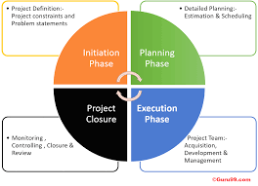

**The Initiation Phase:**

* The initiation phase aims to define and authorize the project. **.**

**The Planning Phase:**

* The purpose of this phase is to lay down a detailed strategy of how the project has to be performed and how to make it a success
* Strategic Planning- overall approach to the project
* Implementation Planning-ways to apply the decisions

**The Execution Phase:**

* In this phase, the decisions and activities defined during the planning phase are implemented.

**The Termination Phase:**

* This is the last phase of any project, and it marks the official closure of the project.

**SYSTEM ARCHITURE**

GUI COMPONENT

Login,Registation,HRA,.EMP,PME

**Presentation Layer**

DATABASE

Table-Employee,Skill,Job,

EmpSkill,EmpJob

JRE

Code

JDBC Connection

C

**Application Layer**

**Data Accese Layer**

1. **Tier Architecture**

* **Presentation Layer** that sends content to browsers in the form of HTML/JS/CSS. This might leverage frameworks like React, Angular, Ember, Aurora, etc.
* **Application Layer** that uses an application server and processes the business logic for the application. This might be written in C#, Java, C++, Python, Ruby, etc.
* **Data Layer** which is a database management system that provides access to application data. This could be MSSQL, MySQL, Oracle, or PostgreSQL, Mongo, etc.

**SOFTWARE SPECIFICATION REQUIREMENTS**

**Table of Contents**

1. **Introduction**
   1. Purpose
   2. Scope
   3. Definitions, acronyms and abbreviations
   4. References
   5. Overview
2. **General Description**

2.1 Product perspective

2.2 Product functions

2.3 User characteristics

2.4 Constraints

2.5 Assumption and dependencies

1. **Specific Requirements**

3.1 Functional requirements

3.2 Non-functional requirements

3.3 External interface requirements

3.4 Performance requirements

3.5 Design constraints

3.6 Attributes

3.7 Other requirements

1. **Appendices**
2. **Index**

**HIGH LEVEL USE CASE DIAGRAGRAMS**

* High level diagrams that would be used for developing a Software product. The diagram provides an overview entire system, identifying the main component that would be developed for the product and their interface.

**HR PM EMP**

Application Layer

SQL DB

Business Logic.

User interface

**LOW LEVEL USE CASE DIAGRAMS**

**HREHOME**

* HR can view employee information
* HR can update employee information
* HR can update requested skills of the employe

PMP.

.

**.**

HR..

HOME

**PMEHOME**

* PME can view Skill of the employee
* PME can add a new job for employee
* PME can view all project jobes

PMHOME

**EMPHOME**

* Employee can view his/her own information
* Employee can request to HR for Updating his/her information
* Employee apply for job assigned by the pme

EMPHOME

**USER INTERFACE DESIGN**

.

**Login Form**

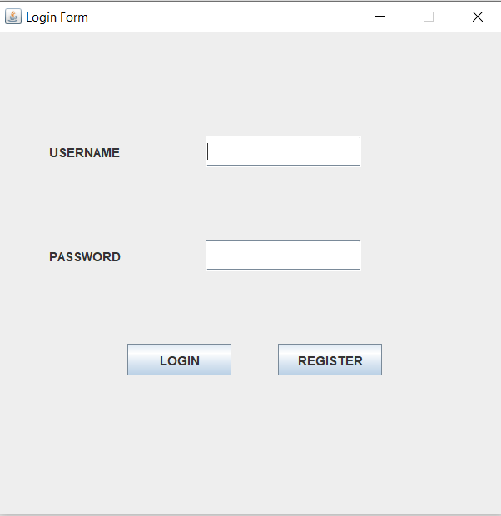

**Registration Form**

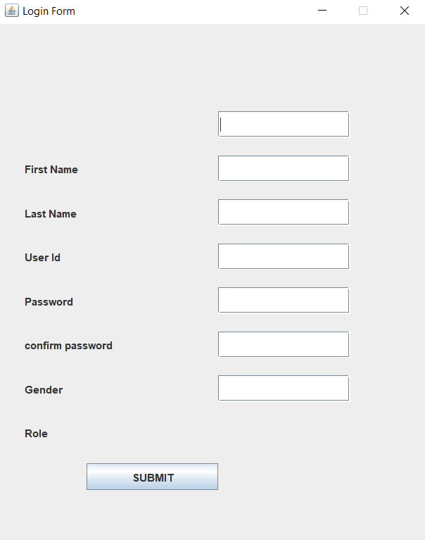

**SYSTEMS INPUT AND OUTPUT DESIGN**

**DATABASE STRUCTURE**

**use pcsdb;**

**create table Employee(**

**empId int auto_increment,**

**FristName varchar(30)not null,**

**LastName varchar(30) not null,**

**UserId varchar(30)not null,**

**Password varchar(20)not null,**

**Role varchar(3)not null,**

**Gender varchar(10)not null,**

**Active varchar(10)not null,**

**primary key(empId)**

**);**

**insert into Employee(FristName, LastName,UserId,Password,Role,Gender,Active)**

**values("Joyasree","Mondal","Joya123","pass@123","HRA","Female","Active")**

**select*from Employee;**

**create table EmpSkill(**

**ESId int auto_increment,**

**EmployeeId varchar(30) not null,**

**SkillId varchar(20) not null,**

**ExpYear varchar(30) not null,**

**primary key(ESId)**

**);**

**insert into EmpSkill(EmployeeId,SkillId,expYear)**

**values("3401","436","30/12/2020")**

**select*from EmpSkill**

**create table EmpJob(**

**EJId int auto_increment,**

**EmployeeId varchar(30) not null,**

**JobId varchar (20) not null,**

**Recruited varchar(30) not null,**

**primary key(EJId)**

**);**

**insert into EmpJob(EmployeeId,JobId,Recruited)**

**values("4501","053","Professional Associations")**

**select *from EmpJob;**

**create table Job(**

**JobId int auto_increment,**

**Jobtitle varchar(30) not null,**

**JobDescription varchar (40) not null,**

**companyName varchar (30) not null,**

**Location varchar(30) not null,**

**keySkill varchar(20) not null,**

**Salary varchar (30) not null,**

**Active varchar(30) not null,**

**primary key(JobId)**

**);**

**insert into Job(JobTitle,Jobdescription,companyName,Location,keySkill,salary,Active)**

**values("project Manager","self confidance","TCS","SaltLak","Managment","24000","Active")**

**select*from Job**